**ГРУППА К8-224**



**СЕРВИС ПО ОРГАНИЗАЦИИ И ПОИСКУ МЕРОПРИЯТИЙ.**

**ПРОБНОЕ НАГРУЗОЧНОЕ ТЕСТИРОВАНИЕ**

|  |
| --- |
|  |
| «PartySurfing» |

**Москва 2014 - 2015**

**Содержание**

1. Пробное нагрузочное тестирование. 3

1.1. Результаты 3

1.1.1 Таблицы результатов 3

1.1.2 Графики результатов 6

История изменений

|  |  |  |  |  |
| --- | --- | --- | --- | --- |
| Версия | Изменения | Дата | Автор | Подпись |
| 1.0 | Черновик | 01.04.2015 | Сиволоб Иван |  |
| 1.1 | Редактирование документа | 16.04.2015 | Македонская Евгения |  |
|  |  |  |  |  |
|  |  |  |  |  |
|  |  |  |  |  |
|  |  |  |  |  |

# Пробное нагрузочное тестирование.

**Тестирование производительности.**

## Результаты

### Таблицы результатов

**Summary**

|  |  |  |  |  |  |  |  |  |  |
| --- | --- | --- | --- | --- | --- | --- | --- | --- | --- |
| Profile | Successful sessions | Failed sessions | Successful pages | Failed pages | Successful hits | Failed hits | Total KBytes sent | Total KBytes received | Avg response time, sec (with page elements) |
| Profile1 | 0 | 3 | 10 | 3 | 43 | 28 | 27.7 | 1899 | 5.40(305) |

**Number of active users**

|  |  |  |  |  |  |  |  |  |  |  |
| --- | --- | --- | --- | --- | --- | --- | --- | --- | --- | --- |
| Profile | 0:00:00-0:01:00 | 0:01:00-0:02:00 | 0:02:00-0:03:00 | 0:03:00-0:04:00 | 0:04:00-0:05:00 | 0:05:00-0:06:00 | 0:06:00-0:07:00 | 0:07:00-0:08:00 | 0:08:00-0:09:00 | 0:09:00-0:10:00 |
| Profile1 | 4 | 9 | 14 | 19 | 20 | 20 | 20 | 20 | 20 | 20 |
| Total | 4 | 9 | 14 | 19 | 20 | 20 | 20 | 20 | 20 | 20 |

**Successful sessions (Failed sessions)**

|  |  |  |  |  |  |  |  |  |  |  |  |
| --- | --- | --- | --- | --- | --- | --- | --- | --- | --- | --- | --- |
| Profile | 0:00:00-0:01:00 | 0:01:00-0:02:00 | 0:02:00-0:03:00 | 0:03:00-0:04:00 | 0:04:00-0:05:00 | 0:05:00-0:06:00 | 0:06:00-0:07:00 | 0:07:00-0:08:00 | 0:08:00-0:09:00 | 0:09:00-0:10:00 | Total |
| Profile1 | 0(0) | 0(0) | 0(0) | 0(0) | 0(0) | 0(1) | 0(0) | 0(1) | 0(0) | 0(1) | 0(3) |
| Total | 0(0) | 0(0) | 0(0) | 0(0) | 0(0) | 0(1) | 0(0) | 0(1) | 0(0) | 0(1) | 0(3) |

**Successful pages (Failed pages)**

|  |  |  |  |  |  |  |  |  |  |  |  |
| --- | --- | --- | --- | --- | --- | --- | --- | --- | --- | --- | --- |
| Profile | 0:00:00-0:01:00 | 0:01:00-0:02:00 | 0:02:00-0:03:00 | 0:03:00-0:04:00 | 0:04:00-0:05:00 | 0:05:00-0:06:00 | 0:06:00-0:07:00 | 0:07:00-0:08:00 | 0:08:00-0:09:00 | 0:09:00-0:10:00 | Total |
| Profile1 | 2(0) | 0(0) | 0(0) | 0(0) | 1(0) | 0(1) | 0(0) | 1(1) | 0(0) | 6(1) | 10(3) |
| Total | 2(0) | 0(0) | 0(0) | 0(0) | 1(0) | 0(1) | 0(0) | 1(1) | 0(0) | 6(1) | 10(3) |

**Successful hits (Failed hits)**

|  |  |  |  |  |  |  |  |  |  |  |  |
| --- | --- | --- | --- | --- | --- | --- | --- | --- | --- | --- | --- |
| Profile | 0:00:00-0:01:00 | 0:01:00-0:02:00 | 0:02:00-0:03:00 | 0:03:00-0:04:00 | 0:04:00-0:05:00 | 0:05:00-0:06:00 | 0:06:00-0:07:00 | 0:07:00-0:08:00 | 0:08:00-0:09:00 | 0:09:00-0:10:00 | Total |
| Profile1 | 9(0) | 2(1) | 0(0) | 2(2) | 5(3) | 2(7) | 2(3) | 7(3) | 2(4) | 12(5) | 43(28) |
| Total | 9(0) | 2(1) | 0(0) | 2(2) | 5(3) | 2(7) | 2(3) | 7(3) | 2(4) | 12(5) | 43(28) |

**Successful sessions per second**

|  |  |  |  |  |  |  |  |  |  |  |  |
| --- | --- | --- | --- | --- | --- | --- | --- | --- | --- | --- | --- |
| Profile | 0:00:00-0:01:00 | 0:01:00-0:02:00 | 0:02:00-0:03:00 | 0:03:00-0:04:00 | 0:04:00-0:05:00 | 0:05:00-0:06:00 | 0:06:00-0:07:00 | 0:07:00-0:08:00 | 0:08:00-0:09:00 | 0:09:00-0:10:00 | Total |
| Profile1 | 0 | 0 | 0 | 0 | 0 | 0 | 0 | 0 | 0 | 0 | 0 |
| Total | 0 | 0 | 0 | 0 | 0 | 0 | 0 | 0 | 0 | 0 | 0 |

**Successful pages per second**

|  |  |  |  |  |  |  |  |  |  |  |  |
| --- | --- | --- | --- | --- | --- | --- | --- | --- | --- | --- | --- |
| Profile | 0:00:00-0:01:00 | 0:01:00-0:02:00 | 0:02:00-0:03:00 | 0:03:00-0:04:00 | 0:04:00-0:05:00 | 0:05:00-0:06:00 | 0:06:00-0:07:00 | 0:07:00-0:08:00 | 0:08:00-0:09:00 | 0:09:00-0:10:00 | Total |
| Profile1 | 0.03 | 0 | 0 | 0 | 0.02 | 0 | 0 | 0.02 | 0 | 0.10 | 0.02 |
| Total | 0.03 | 0 | 0 | 0 | 0.02 | 0 | 0 | 0.02 | 0 | 0.10 | 0.02 |

**Successful hits per second**

|  |  |  |  |  |  |  |  |  |  |  |  |
| --- | --- | --- | --- | --- | --- | --- | --- | --- | --- | --- | --- |
| Profile | 0:00:00-0:01:00 | 0:01:00-0:02:00 | 0:02:00-0:03:00 | 0:03:00-0:04:00 | 0:04:00-0:05:00 | 0:05:00-0:06:00 | 0:06:00-0:07:00 | 0:07:00-0:08:00 | 0:08:00-0:09:00 | 0:09:00-0:10:00 | Total |
| Profile1 | 0.15 | 0.03 | 0 | 0.03 | 0.08 | 0.03 | 0.03 | 0.12 | 0.03 | 0.20 | 0.07 |
| Total | 0.15 | 0.03 | 0 | 0.03 | 0.08 | 0.03 | 0.03 | 0.12 | 0.03 | 0.20 | 0.07 |

**Failed sessions**

|  |  |  |  |  |  |  |  |  |  |  |  |
| --- | --- | --- | --- | --- | --- | --- | --- | --- | --- | --- | --- |
| Profile | 0:00:00-0:01:00 | 0:01:00-0:02:00 | 0:02:00-0:03:00 | 0:03:00-0:04:00 | 0:04:00-0:05:00 | 0:05:00-0:06:00 | 0:06:00-0:07:00 | 0:07:00-0:08:00 | 0:08:00-0:09:00 | 0:09:00-0:10:00 | Total |
| Profile1 | 0 | 0 | 0 | 0 | 0 | 1 | 0 | 1 | 0 | 1 | 3 |
| Total | 0 | 0 | 0 | 0 | 0 | 1 | 0 | 1 | 0 | 1 | 3 |

**Failed pages**

|  |  |  |  |  |  |  |  |  |  |  |  |
| --- | --- | --- | --- | --- | --- | --- | --- | --- | --- | --- | --- |
| Profile | 0:00:00-0:01:00 | 0:01:00-0:02:00 | 0:02:00-0:03:00 | 0:03:00-0:04:00 | 0:04:00-0:05:00 | 0:05:00-0:06:00 | 0:06:00-0:07:00 | 0:07:00-0:08:00 | 0:08:00-0:09:00 | 0:09:00-0:10:00 | Total |
| Profile1 | 0 | 0 | 0 | 0 | 0 | 1 | 0 | 1 | 0 | 1 | 3 |
| Total | 0 | 0 | 0 | 0 | 0 | 1 | 0 | 1 | 0 | 1 | 3 |

**Failed hits**

|  |  |  |  |  |  |  |  |  |  |  |  |
| --- | --- | --- | --- | --- | --- | --- | --- | --- | --- | --- | --- |
| Profile | 0:00:00-0:01:00 | 0:01:00-0:02:00 | 0:02:00-0:03:00 | 0:03:00-0:04:00 | 0:04:00-0:05:00 | 0:05:00-0:06:00 | 0:06:00-0:07:00 | 0:07:00-0:08:00 | 0:08:00-0:09:00 | 0:09:00-0:10:00 | Total |
| Profile1 | 0 | 1 | 0 | 2 | 3 | 7 | 3 | 3 | 4 | 5 | 28 |
| Total | 0 | 1 | 0 | 2 | 3 | 7 | 3 | 3 | 4 | 5 | 28 |

**Response codes**

|  |  |  |  |
| --- | --- | --- | --- |
| Code | Request | Pages | Hits |
| Profile1 | - | 13 | 71 |
| 200 OK | Profile1.All | 10 | 43 |
| 200 OK | Profile1.page_1: http://party-prototype.herokuapp.com/ | 7 | 38 |
|  | Profile1.page_2: https://maps.googleapis.com:443/maps/api/js | 2 | 4 |
|  | Profile1.page_3: http://party-prototype.herokuapp.com/parties | 1 | 1 |
| Timeout | Profile1.page_1: http://party-prototype.herokuapp.com/ | 0 | 21 |
|  | Profile1.page_3: http://party-prototype.herokuapp.com/parties | 0 | 2 |
| Network error | Profile1.page_1: http://party-prototype.herokuapp.com/ | 0 | 1 |
|  | Profile1.page_2: https://maps.googleapis.com:443/maps/api/js | 3 | 3 |
|  | Profile1.page_3: http://party-prototype.herokuapp.com/parties | 0 | 1 |

**HTTP errors on pages (hits) as a % of all completed pages (hits)**

|  |  |  |  |  |  |  |  |  |  |  |  |
| --- | --- | --- | --- | --- | --- | --- | --- | --- | --- | --- | --- |
| Profile | 0:00:00-0:01:00 | 0:01:00-0:02:00 | 0:02:00-0:03:00 | 0:03:00-0:04:00 | 0:04:00-0:05:00 | 0:05:00-0:06:00 | 0:06:00-0:07:00 | 0:07:00-0:08:00 | 0:08:00-0:09:00 | 0:09:00-0:10:00 | Total |
| Profile1 | 0(0) | - | - | - | 0(0) | 0(0) | - | 0(0) | - | 0(0) | 0(0) |
| Total | 0(0) | - | - | - | 0(0) | 0(0) | - | 0(0) | - | 0(0) | 0(0) |

**Timeouts on pages (hits) as a % of all completed pages (hits)**

|  |  |  |  |  |  |  |  |  |  |  |  |
| --- | --- | --- | --- | --- | --- | --- | --- | --- | --- | --- | --- |
| Profile | 0:00:00-0:01:00 | 0:01:00-0:02:00 | 0:02:00-0:03:00 | 0:03:00-0:04:00 | 0:04:00-0:05:00 | 0:05:00-0:06:00 | 0:06:00-0:07:00 | 0:07:00-0:08:00 | 0:08:00-0:09:00 | 0:09:00-0:10:00 | Total |
| Profile1 | 0(0) | - | - | - | 0(37.5) | 0(66.7) | - | 0(20) | - | 0(17.6) | 0(32.4) |
| Total | 0(0) | - | - | - | 0(37.5) | 0(66.7) | - | 0(20) | - | 0(17.6) | 0(32.4) |

**Total errors on pages (hits) as a % of all completed pages (hits)**

|  |  |  |  |  |  |  |  |  |  |  |  |
| --- | --- | --- | --- | --- | --- | --- | --- | --- | --- | --- | --- |
| Profile | 0:00:00-0:01:00 | 0:01:00-0:02:00 | 0:02:00-0:03:00 | 0:03:00-0:04:00 | 0:04:00-0:05:00 | 0:05:00-0:06:00 | 0:06:00-0:07:00 | 0:07:00-0:08:00 | 0:08:00-0:09:00 | 0:09:00-0:10:00 | Total |
| Profile1 | 0(0) | - | - | - | 0(37.5) | 100(77.8) | - | 50(30.0) | - | 14.3(29.4) | 23.1(39.4) |
| Total | 0(0) | - | - | - | 0(37.5) | 100(77.8) | - | 50(30.0) | - | 14.3(29.4) | 23.1(39.4) |

### Графики результатов

Общая производительность

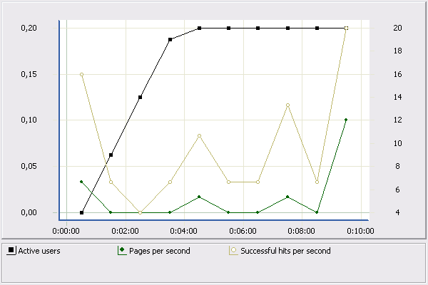

Ошибки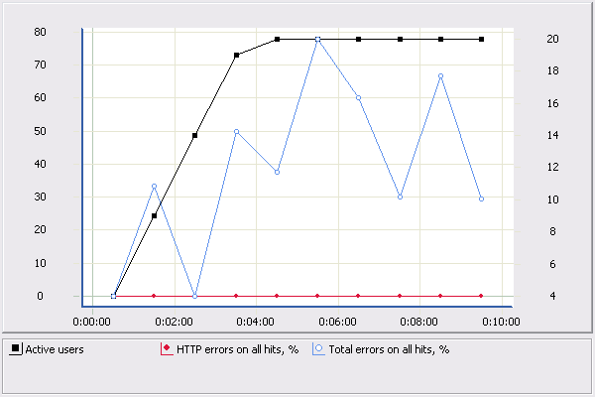

Средняя пропускная способность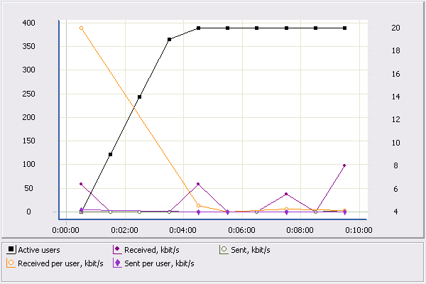

Среднее время отклика (без элементов страницы)

Для страницы: http://party-prototype.herokuapp.com/

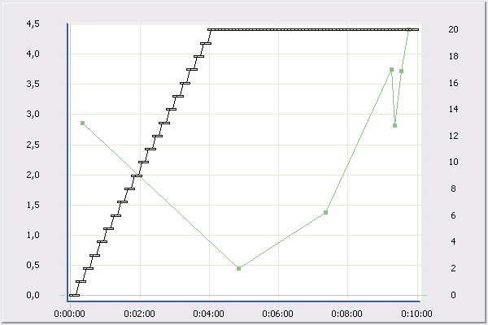скачанные файлы.png